- The Monetary Policy Committee voted to keep Bank Rate at 5.25% at May's meeting, but it also sent a clear message that a summer rate cut is likely. This could come as soon as June if data on pay and inflation data come in at, or below, expectations.
- Three points underpin the MPC's dovish message. Deputy Governor Dave Ramsden voted for a rate cut for the first time. The MPC's new forecasts showed inflation below target from two years out. And the minutes included new language around the timing of the first cut, referring to considering "forthcoming data releases". Previously it had not indicated a timeframe.
- The MPC has confirmed our long-held view that the April data for pay growth and services inflation will be key – both will be available before the next MPC meeting on June 20. Whether the first cut comes in June or August remains finely balanced. For the time being, our central forecast remains a first cut in June, and a total of 75bps of rate cuts this year. But we will revisit our rate call when the April inflation data is published on May 22.
The Bank of England's Monetary Policy Committee voted to keep Bank Rate unchanged at 5.25% at the May meeting, in line with our forecast. The vote narrowed to 7-2, with BoE Deputy Governor Dave Ramsden joining Swati Dhingra in voting for a 25bps cut. Given his recent speech, we had thought that it was possible Ramsden would vote for a rate cut, but it was not our central forecast. His decision appears to be a significant signal of the way that sentiment is changing on the committee, and was accompanied by two other dovish signals that suggested rate cuts are imminent.
The first was a lower inflation projection throughout the forecast horizon (Chart 1). In February, the MPC had forecast that inflation would overshoot in the medium-term, sending a message that market pricing for interest rates was too low. Its May forecast was based on market expectations that were 60bps-70bps higher for most of the forecast horizon. And with the new forecast showing inflation below the 2% target from two years onwards, the MPC effectively indicated that market pricing was now too high.
Chart 1: The MPC's sub-2% inflation forecast implies market pricing is too high
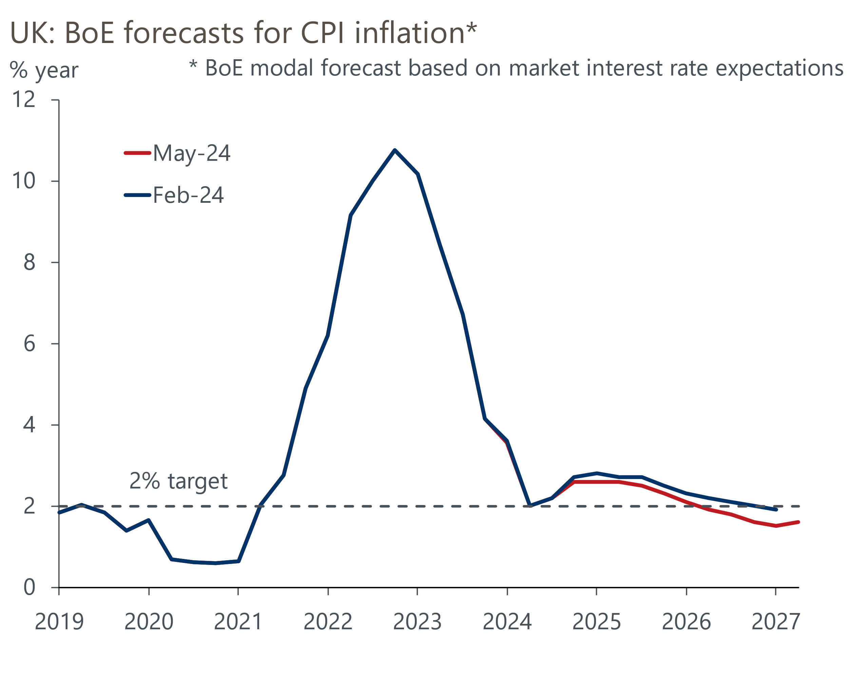
Source: Bank of England Monetary Policy Report

The higher market curve was one factor explaining the lower inflation forecast. The MPC also revised its judgements on the impact of past increases in import prices and the likely evolution of second-round effects. On the former, based on BoE staff research the committee decided that a greater proportion of past increases in import prices had already passed through to consumer prices, compared with previous inflation projections. The MPC also judged that second-round effects on domestic prices and wages will fade more quickly than previously thought.
The other dovish signal was a change to the language in the minutes. The May minutes stated that the MPC "would consider forthcoming data releases" in assessing whether the risks from inflation persistence were receding. Previously no timeframe had been indicated, so this change suggests a greater urgency. In his opening remarks at the press conference, Bailey drew attention to the change, emphasising its significance.
At the press conference, there was further discussion of the idea that policy would still be restrictive even after the MPC had started to cut rates. Bailey reiterated his views that inflation dynamics are different in the US and UK, and that the Fed's behaviour would not influence the timing of a UK interest rate cut.
Taken together, these signals give a clear indication that the MPC expects to be in a position to cut interest rates very soon. Indeed, data permitting, that move could come as soon as the next meeting in June – Bailey said that a June cut was neither "ruled out" nor "a fait accompli".
We've long argued that the April data for pay and inflation will be key. The pay data will show the impact of the near-10% rise in the national living wage, while the inflation data will show the impact on core inflation of the annual increases for index-linked contracts and regulated prices. The inflation data will be published on May 22. The average weekly earnings series will come out on June 11, with real-time HMRC data available on May 14. So the MPC will have all of the relevant data at its June meeting. Projections by BoE staff have acted as an informal benchmark against which we can measure incoming data that matters to the MPC. The forecasts for the MPC's two key measures of inflation persistence – services inflation and private sector regular pay – have been raised since February, so the scope for upside surprises to derail a potential rate cut appears to be smaller (Chart 2). Indeed, our current forecasts are lower.
Chart 2: The MPC has increased its short-term forecasts for key measures of inflation persistence
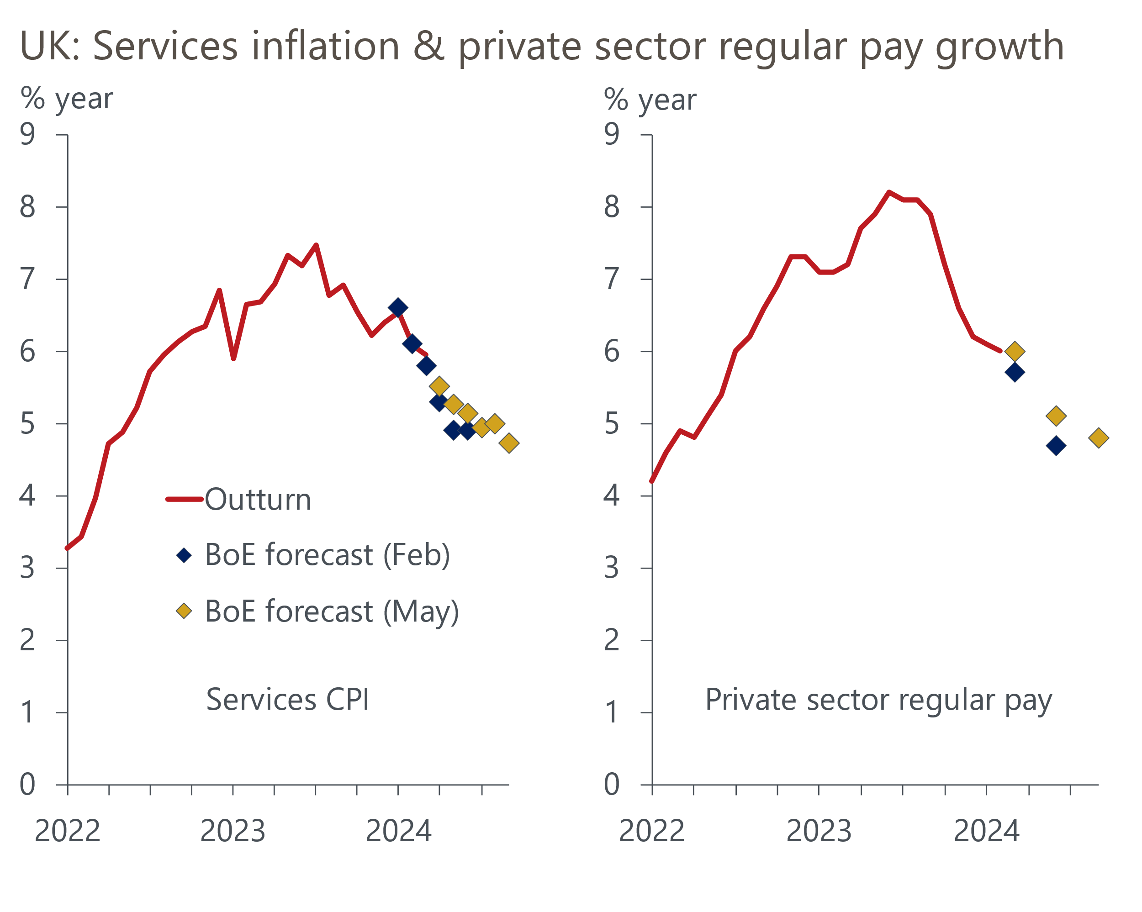
Sources: Haver Analytics, Bank of England Monetary Policy Report
The results of the BoE's April Decision Maker Panel also provided some reassurance that the data will support a rate cut. Despite that month's NLW rise, annual wage growth slowed to 5.9%, from 6.1% in March. Though the fall in the annual growth rate was small, the scale of the NLW rise meant that pay growth could have risen. And it suggests that the scenario of a large rise in the NLW having a ripple effect higher up the pay distribution is not playing out.
Whether the first cut comes in June or August is finely balanced, and we will revisit our call when the April inflation data is published in a couple of weeks' time. As things stand, our central forecast remains that the first cut will happen in June. We still expect a total of 75bps of cuts this year, consistent with the BoE's signal that market pricing is too hawkish.

Key passages from the MPC minutes
“Seven members judged that maintaining Bank Rate at 5.25% was warranted at this meeting. Headline CPI inflation had continued to fall back, in part owing to base effects and external effects from goods prices. The restrictive stance of monetary policy was weighing on activity in the real economy, was leading to a looser labour market and was bearing down on inflationary pressures. Key indicators of inflation persistence were moderating broadly as expected, although they remained elevated. There was a range of views among these members regarding the risks around the assumptions on persistence embodied in the May CPI projection. There was also a range of views about the extent of the evidence that was likely to be needed to warrant a change in Bank Rate, and the degree to which these members anticipated that incremental information in forthcoming data outturns would lead them to update materially their assessment of inflation persistence. All of these members would continue to consider the degree of restrictiveness of policy at each meeting."
Our interpretation: This is similar to the equivalent paragraph of the March minutes. Subsequent speeches have suggested external members Mann, Haskel, and Greene are on the more hawkish side of this group. The internals appear likely to be on the more dovish side. We can envisage three of Bailey, Broadbent (or, beyond June, Lombardelli), Breedon, and Pill to join Ramsden and Dhingra in voting for a cut soon.
"Two members preferred a 0.25 percentage point reduction in Bank Rate at this meeting. For these members, Bank Rate needed to become less restrictive now to enable a smooth and gradual transition in the policy stance, and to account for lags in transmission. Consumer price inflation was already, and had been for some time, on a firm downward trajectory. The latest forecasts showed inflation returning close to the target in the short term, and this was consistent with forward-looking indicators of output price inflation falling behind input price inflation. As the outlook for demand remained subdued, with vacancies continuing to fall and nominal pay growth easing, the risks to inflation returning sustainably to the target in the medium term were to the downside."
Our interpretation: Ramsden hinted that he might switch camps in a recent speech, but we were a little surprised he moved so quickly. We view Ramsden's change of vote as emblematic of the way that sentiment among the MPC is moving.
"The MPC remained prepared to adjust monetary policy as warranted by economic data to return inflation to the 2% target sustainably. It would, therefore, continue to monitor closely indications of persistent inflationary pressures and resilience in the economy as a whole, including a range of measures of the underlying tightness of labour market conditions, wage growth and services price inflation. The Committee would consider forthcoming data releases and how these informed the assessment that the risks from inflation persistence were receding. On that basis, the Committee would keep under review for how long Bank Rate should be maintained at its current level."
Our interpretation: Mention of considering "forthcoming data releases" is a new inclusion this month. Bailey drew attention to its importance in the press conference, showing this is designed to signal greater urgency than before, and reiterate that June is a 'live' meeting.

